LAB 6
Spring 2011, BESE- 15
Using Databases with asp.net

Objective

This lab has the objective to familiarize students with:
- Connecting to and accessing a database through code.

Submission Requirements
By the end of the lab.

Task:

Create a student login form. Verify the details provided against those in the database. Show the details of student and provide the facility for editing.

DATABASES WITH ASP.NET
- Create a new website.
- Create a database with a table for storing user details such as user name, user id, password, contact number, [login] status.
- On first page add two labels, one displaying “User ID” and the other displaying “Password”.
- Add two textboxes, first to get value of user id and second to get value of password.
- Add a submit button.

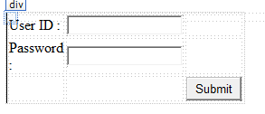

- Add a second page with a label for displaying name of user and one for displaying “You are logged in as:”

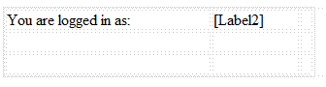

- Behind the submit button add the following code:

In this step a SQL connection is created. Based on this connection we access the database.

- Generate the SQL Query.

- Now open a database connection.
conn.open();

- Once the connection is open, we can read or write to the database. To read from the database create a ‘DataReader’ object.

- Create a SQL command using the connection string and query string. The ExecuteReader() retrieves some rows from the database depending on the query string. The rows are stored in datareader object.
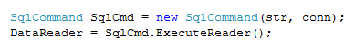

- Once the rows are retrieved, we can extract desired values.

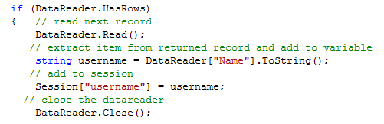

- Datareader object is exclusively for getting data from database. To write data into it we create a new sql command based on a different query.

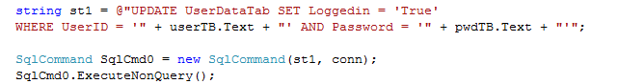

- Close the database connection using conn.Close();
- Redirect to the next page and display the value stored in session on this page.

